Department of Mathematics and Computer Science

**Graduate Capstone in Computer Science MyChat Application** Prof: Saleh Aliyari

Submitted by-

Shasheen Bandodkar

Aditee Varhadi

1

Department of Mathematics and Computer Science

**Backlogs**

**02/19/2020**

|  |  |  |  |  |
| --- | --- | --- | --- | --- |
| **To Do** |  | **Doing** |  | **Done** |

Install dependencies and

setup framework to develop

application.

Develop GUI for the

application.

Setup backend with node.js

Design login page

Establish client server

connection.

Accounted event handling for

user login page.

**02/25/2020**

|  |  |  |  |  |  |  |  |  |
| --- | --- | --- | --- | --- | --- | --- | --- | --- |
|  | **To Do** |  |  | **Doing** | |  | **Done** | |
|  |  |  |  |  |  |  |  |  |
|  |  |  |  |  |  | Install dependencies and | | |
|  |  |  |  |  |  | setup framework to develop | | |
|  |  |  |  |  |  | application. | | |
|  |  |  |  |  |  |  | | |
|  |  |  |  |  |  | Develop GUI for the | | |
|  |  |  |  |  |  | application. | | |
|  |  |  |  |  |  |  | | |
|  |  |  |  |  |  | Setup backend with node.js | | |
|  |  |  |  |  |  |  | | |
|  |  |  |  |  |  | Design login page | | |
|  |  |  |  | | |  |  |  |
|  |  |  | Establishing client server | | |  |  |  |
|  |  |  | connection. | | |  |  |  |
|  |  |  |  | | |  |  |  |
|  |  |  | Accounted event handling for | | |  |  |  |
|  |  |  | user login page. | | |  |  |  |
|  |  |  |  |  |  |  |  |  |

2

Department of Mathematics and Computer Science

**02/26/2020**

|  |  |  |  |  |
| --- | --- | --- | --- | --- |
| **To Do** |  | **Doing** |  | **Done** |

Client server connection

JOIN component and Chat

Component

Backend connection

Designing contact page

Adding Users and Establishing

connection

Packet transfer to server

Adding more features for the

homepage

Authentication of user `

Establishing data and user

Privacy

**03/04/2020**

|  |  |  |  |  |  |  |  |  |
| --- | --- | --- | --- | --- | --- | --- | --- | --- |
|  | **To Do** |  |  | **Doing** | |  | **Done** | |
|  |  |  |  |  |  |  |  |  |
|  |  |  |  |  |  | Client server connection | | |
|  |  |  |  |  |  |  | | |
|  |  |  |  |  |  | JOIN component and Chat | | |
|  |  |  |  |  |  | component | | |
|  |  |  |  |  |  |  | | |
|  |  |  |  |  |  | Backend connection | | |
|  |  |  |  |  |  |  | | |
|  |  |  |  |  |  | Designing contact page | | |
|  |  |  |  | | |  |  |  |
|  |  |  | Adding Users and Establishing | | |  |  |  |
|  |  |  | Connection | | |  |  |  |
|  |  |  |  | | |  |  |  |
|  |  |  | Packet transfer from client to server | | |  |  |  |
|  |  |  |  | | |  |  |  |
|  |  |  | Adding more features for the | | |  |  |  |
|  |  |  | Homepage | | |  |  |  |
|  |  |  |  | | |  |  |  |
|  |  |  | Authentication of user | | |  |  |  |
|  |  |  |  |  |  |  |  |  |

3

Department of Mathematics and Computer Science

Establishing data and user

privacy

4

|  |  |  |  |  |  |  |  |  |
| --- | --- | --- | --- | --- | --- | --- | --- | --- |
|  |  |  |  | Department of Mathematics and Computer Science | | | | |
|  |  |  |  | **Summary** | | | | |
|  |  | |  |  |  |  | |  |
|  | **Activity** |  |  |  |  | **Comments** | |  |
|  |  |  |  | | |  |  |  |
| Setting up the framework for | | | Started to do research on best viable route to implement | | | | |  |
| the app and installing the | | | MyChat application. Using javascript and React.js | | | | |  |
| dependencies | | | framework for development. | | | | |  |
|  | | |  | | | | |  |
| Accounted event handling in | | | When user logs in a particular room, the client side | | | | |  |
| the user login page. | | | establishes connection with the server side with the | | | | |  |
|  |  |  | username but not the room number yet | | | | |  |
|  |  |  |  |  |  |  |  |  |

**Screenshots of the work that has been completed:**

1. User connecting with server:

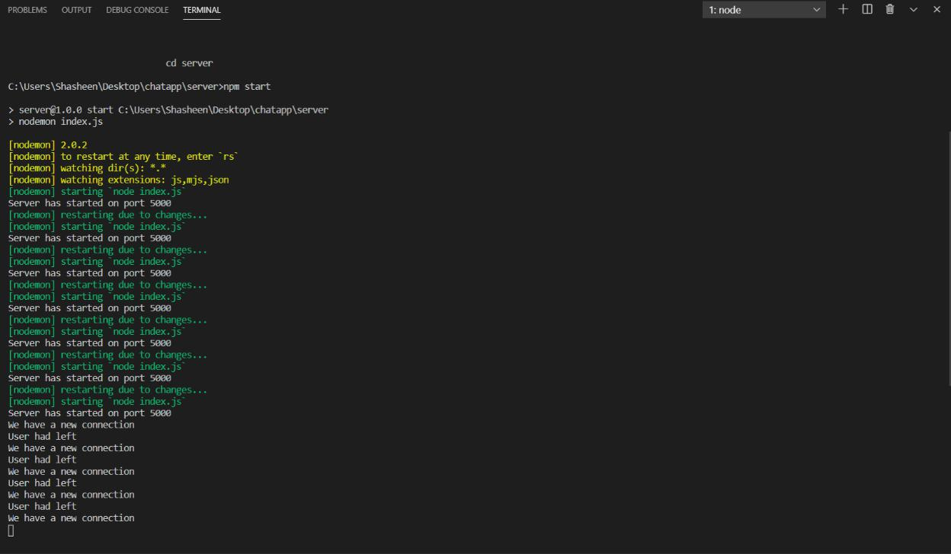

5

Department of Mathematics and Computer Science

2. User as successfully logged in to the chat application and can chat with other users.

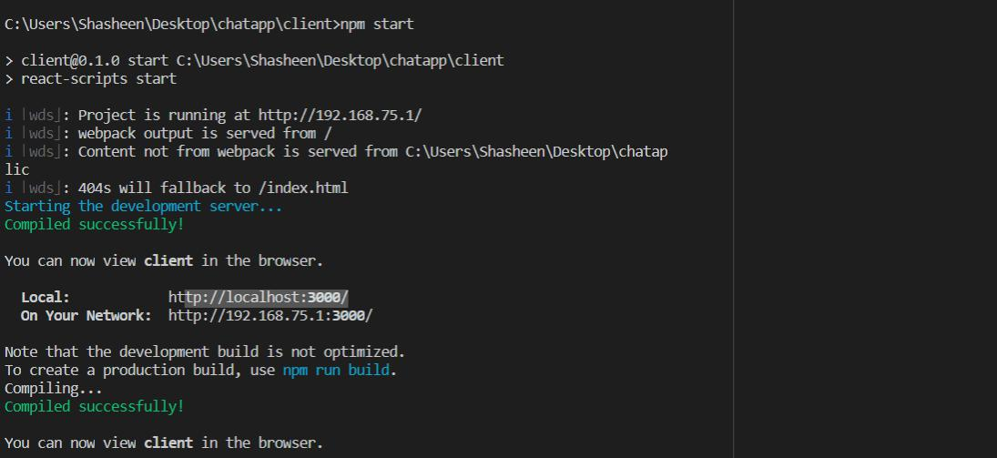

1. Login Page created for initial steps:

User can login through his email and room number

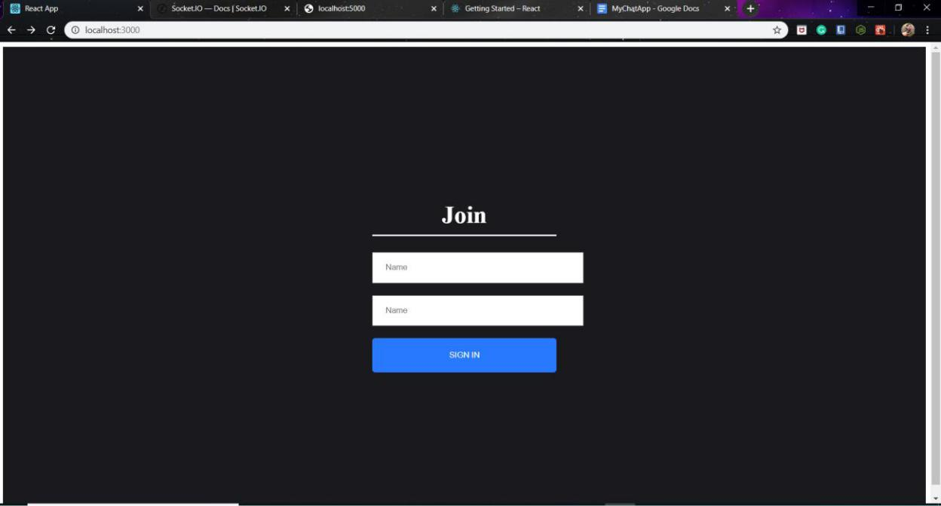

6

Department of Mathematics and Computer Science

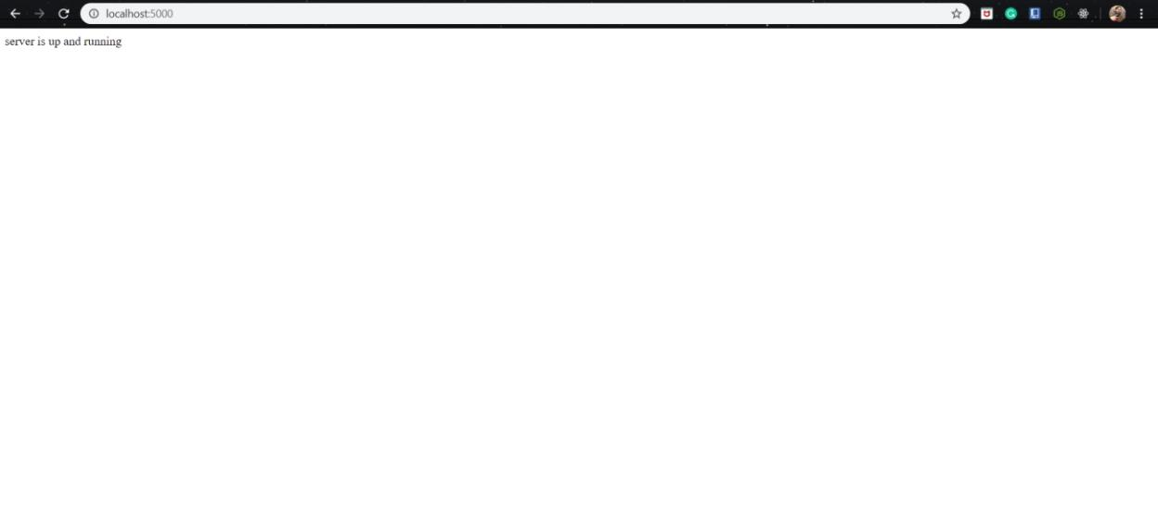

7

Department of Mathematics and Computer Science

4. Frameworks used for developing the frontend and file structure.

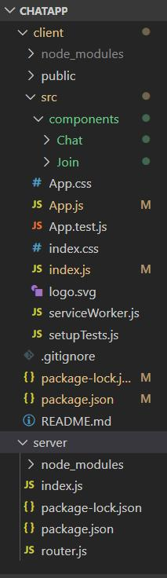

8

The Home Page. This will have more features.

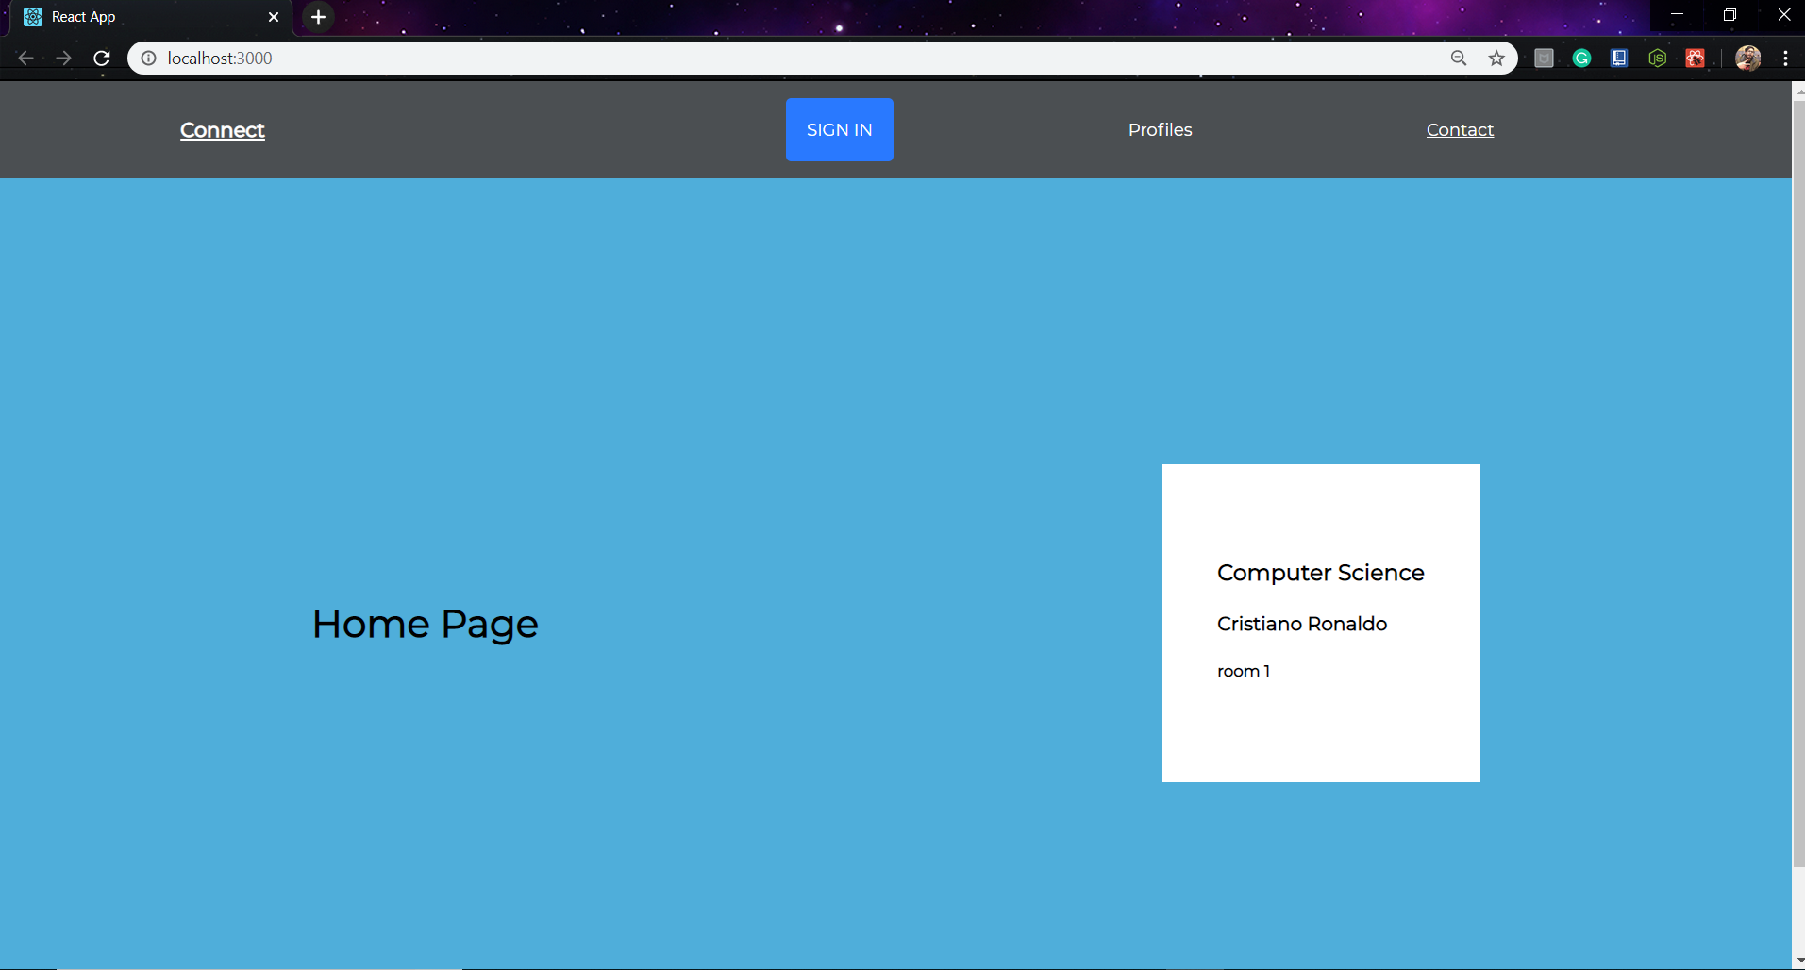

When user wants to enter a chat room. He will enter the user name and the room id.

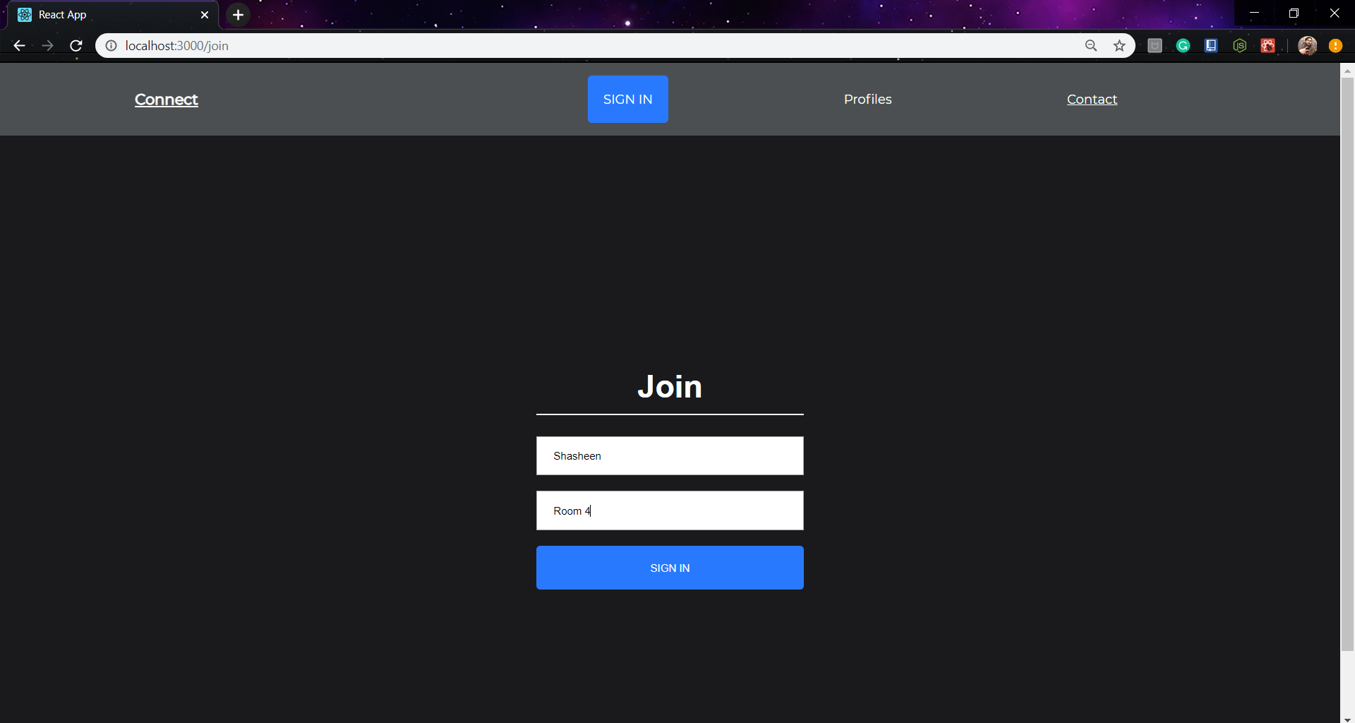

9

The Chat room where the user can now chat with the admin of the particular room. The room the user enters in will be shown with a small feature with the green dot icon showing that the user is now online.

The user can now send messages to the admin of the page.

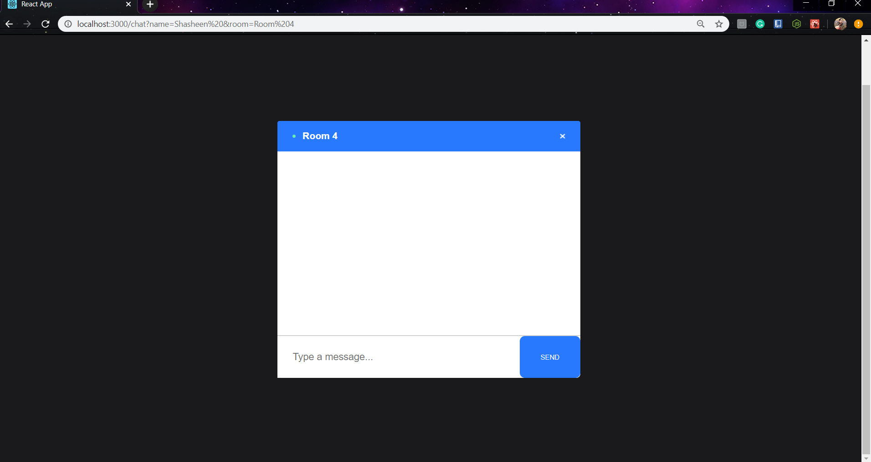

10